AA502 – Time Series
Homework 2

You are an analyst for an international telecommunications company. There are three regions of the world that the company primarily operates in – North America, Europe, and Asia. The regional budget for every month is directly determined by the previous month’s regional sales. To help budget better for the future, you are given the regional data to analyze regional sales separately. The provided data set contains the following variables:
Date Weekly date between 2005 and 2009
Sales_NA Weekly Company Sales in North America (thousands of dollars)
Sales_E Weekly Company Sales in Europe (thousands of dollars)
Sales_A Weekly Company Sales in Asia (thousands of dollars)
Develop a report that includes the following points:
- Import this data into SAS. Take out the last 16 observations and save them for a validation set.
- Plot the data, the ACF, PACF, and the IACF and describe what characteristics you see from all the plots (attach the plots to the report as well).
- 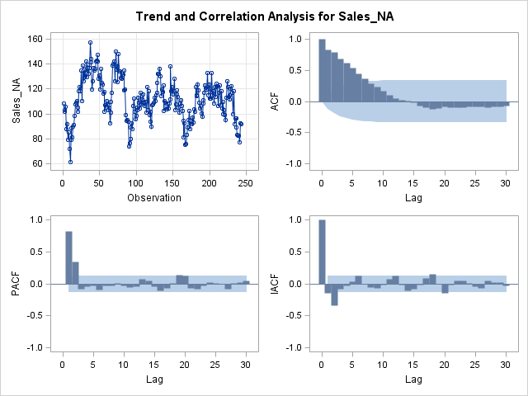
NA:
- The series plot definitely has a cyclical pattern.
- ACF validates it as the first ~8 lags are significant. Looks like an AR model since the lags drop off over time ( not quite exponentially). PACF / IACF also validate this hypothesis since they drop off quickly after the first couple of lags.
- PACF and IACF show significant lags after the first 2-3 and around 20.
- 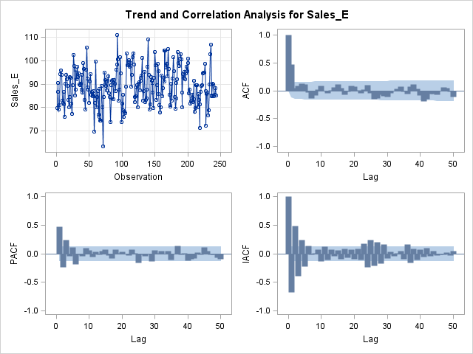
E
- ACF spikes at 2 and around 40. May be a moving average since the ACF drops off while the PACF / IACF have more lags that are significant.
- PACF & IACF show some significant spikes between lags 20-30 and around lag 35
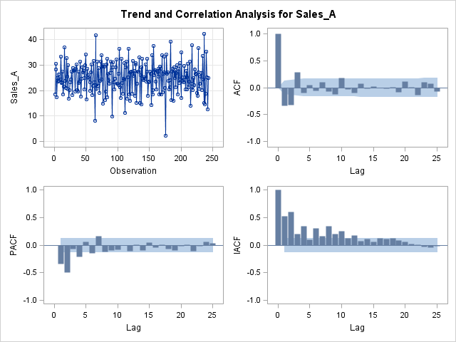
- A
  - PACF / IACF - Significant lags through lag ~13. May be a moving average since the ACF drops off while the PACF / IACF have more lags that are significant.
- Try to identify the appropriate models to use for the three regions. Use plotting patterns and automatic selection techniques to select a few models to try.
Sales_NA
- Minimum Table Value: BIC(2,0) = 4.180331
ARMA(p+d,q) Tentative Order Selection
Tests
SCAN |  |  | ESACF
p+d | q | BIC | p+d | q | BIC
2 | 1 | 4.202655 | 2 | 1 | 4.202655
1 | 2 | 4.194877 | 3 | 1 | 4.199565
0 | 7 | 4.606494 | 1 | 2 | 4.194877
19 | 0 | 4.421203 | 10 | 5 | 4.376565
 |  |  | 0 | 7 | 4.606494
 |  |  | 12 | 6 | 4.43582
 |  |  | 13 | 6 | 4.451453
 |  |  | 21 | 11 | 4.630087
 |  |  | 22 | 7 | 4.556358
Sales_E
Minimum Table Value: BIC(49,37) = -43.5936
ARMA(p+d,q) Tentative Order Selection
Tests
SCAN |  |  | ESACF
p+d | q | BIC | p+d | q | BIC
1 | 3 | 2.177148 | 1 | 2 | 2.180044
5 | 2 | 2.048146 | 5 | 5 | 2.086089
25 | 1 | -34.0169 | 12 | 6 | 1.677654
40 | 0 | -33.5142 | 30 | 13 | .
0 | 41 | . | 29 | 16 | -32.5149
 |  |  | 32 | 14 | -29.5499
 |  |  | 33 | 14 | -31.7129
 |  |  | 27 | 20 | -31.5156
 |  |  | 28 | 20 | -32.1442
 |  |  | 37 | 17 | -34.3759
 |  |  | 43 | 20 | .
 |  |  | 45 | 21 | .
 |  |  | 46 | 20 | .
 |  |  | 48 | 21 | .
 |  |  | 49 | 21 | .
 |  |  | 0 | 41 | .
 |  |  | 50 | 11

Sales_A
Minimum Table Value: BIC(2,2) = 3.052116
ARMA(p+d,q) Tentative Order Selection
Tests
SCAN |  |  | ESACF
p+d | q | BIC | p+d | q | BIC
2 | 5 | 3.092266 | 2 | 5 | 3.092266
8 | 1 | 3.096192 | 6 | 8 | 3.155136
7 | 4 | 3.115292 | 0 | 10 | 3.139515
0 | 10 | 3.139515 | 1 | 10 | 3.152713
22 | 0 | 3.249932 | 16 | 10 | 3.361553
 |  |  | 17 | 10 | 3.372893
 |  |  | 21 | 10 | 3.431887
 |  |  | 23 | 7 | 3.405594
 |  |  | 24 | 7 | 3.409376
 |  |  | 25 | 6 | 3.412929

- Check the white noise plots to see if the residuals are just white noise for each of your models. Attach and comment on these plots.
  - NA: p=2, q=0
- 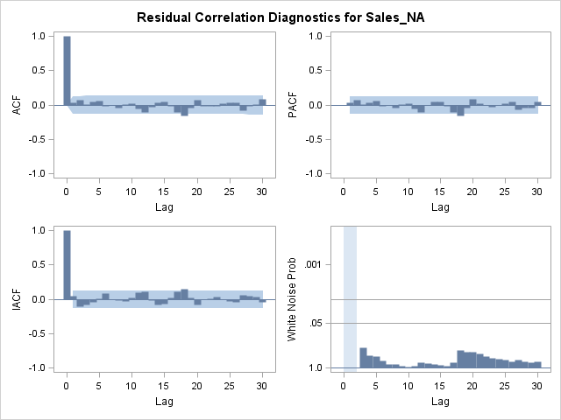
- P=1, Q=2 works well. All terms are significant.
  - 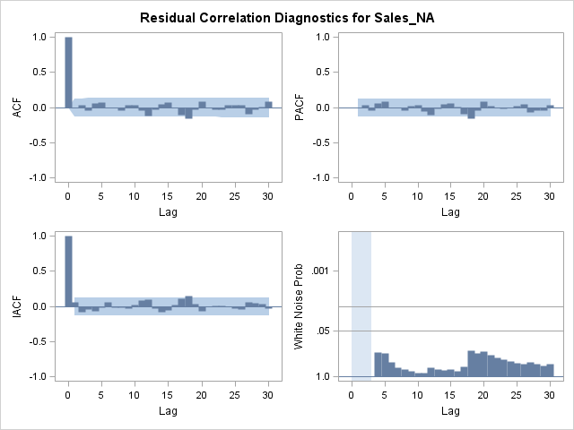
  - Sales_E
  - P=1, q=2
  - 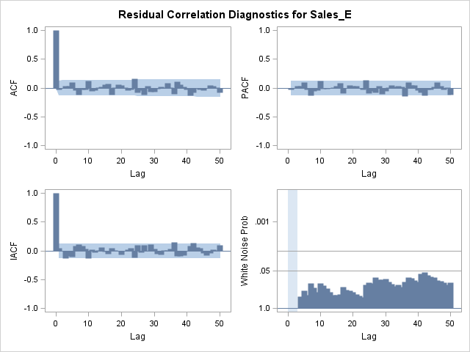
  - P = 5,5 – Charts look good but none of the terms of significant.
- The FORECAST statement in PROC ARIMA is used to forecast out future values and it comes after the estimate statement:
proc arima data=...;
identify var=... nlag=...;
estimate ... method=ml;
forecast lead=...;
run;
quit;
The LEAD option in the above forecast statement controls how many time points into the future that you want to forecast. Use your model to forecast the next 16 observations. Compare these 16 observations to your validation data set. How well do you feel you model did using MAPE? If you do not like your model’s performance, try another model.
Forecasts for variable Sales_NA
Obs | Forecast | Std Error | 95% Confidence Limits
244 | 95.0365 | 9.0813 | 77.2374 | 112.8355
245 | 97.1454 | 10.3917 | 76.7781 | 117.5128
246 | 98.6564 | 12.0759 | 74.9881 | 122.3248
247 | 100.0009 | 13.2584 | 74.0149 | 125.9869
248 | 101.1971 | 14.1246 | 73.5135 | 128.8808
249 | 102.2615 | 14.7743 | 73.3044 | 131.2186
250 | 103.2086 | 15.2691 | 73.2817 | 133.1355
251 | 104.0513 | 15.6498 | 73.3783 | 134.7242
252 | 104.8011 | 15.9447 | 73.5501 | 136.0520
253 | 105.4682 | 16.1743 | 73.7671 | 137.1693
254 | 106.0618 | 16.3539 | 74.0088 | 138.1148
255 | 106.5900 | 16.4946 | 74.2611 | 138.9188
256 | 107.0599 | 16.6052 | 74.5143 | 139.6055
257 | 107.4781 | 16.6922 | 74.7619 | 140.1942
258 | 107.8501 | 16.7608 | 74.9995 | 140.7007
259 | 108.1812 | 16.8149 | 75.2246 | 141.1378
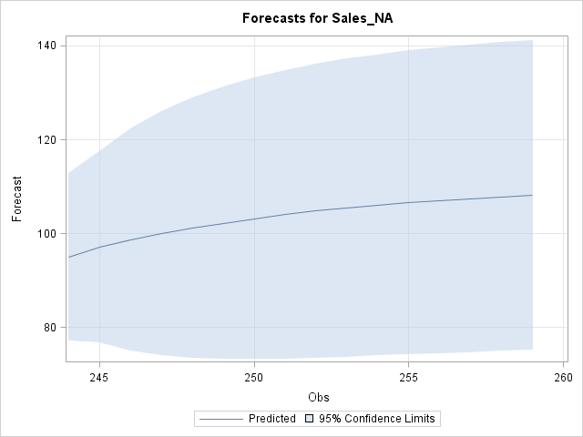
- After selecting your final model, put in the 16 observations from your validation set and use the model you selected previously to forecast the first 12 observations of 2010.

Forecasts for variable Sales_NA
Obs | Forecast | Std Error | 95% Confidence Limits
261 | 108.0484 | 9.1629 | 90.0893 | 126.0074
262 | 106.7413 | 10.4399 | 86.2795 | 127.2031
263 | 107.1013 | 12.1274 | 83.3320 | 130.8707
264 | 107.4234 | 13.3244 | 81.3080 | 133.5387
265 | 107.7114 | 14.2095 | 79.8612 | 135.5615
266 | 107.9690 | 14.8797 | 78.8053 | 137.1326
267 | 108.1993 | 15.3948 | 78.0261 | 138.3726
268 | 108.4054 | 15.7948 | 77.4482 | 139.3627
269 | 108.5897 | 16.1076 | 77.0193 | 140.1601
270 | 108.7546 | 16.3536 | 76.7022 | 140.8069
271 | 108.9020 | 16.5477 | 76.4692 | 141.3348
272 | 109.0338 | 16.7013 | 76.2999 | 141.7678

